# CSK

Contents

CSK 1

System Hardening: 2

Principle of Least Privilege 2

Limit Node Access 3

Remove Obsolete Packages 11

Disable Open ports 14

IAM and Roles in AWS 16

UFW – Uncomplicated Firewall 16

SysCalls 21

Linux Capabilities 41

## System Hardening:

### Principle of Least Privilege

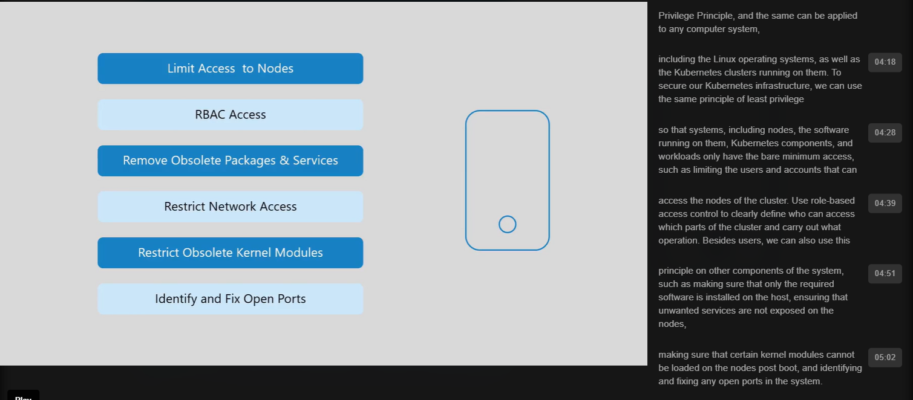

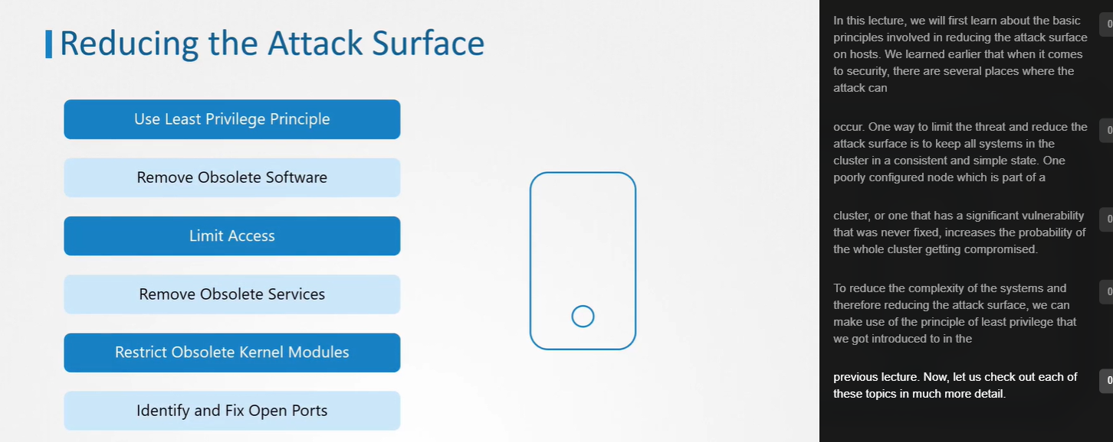

### Limit Node Access

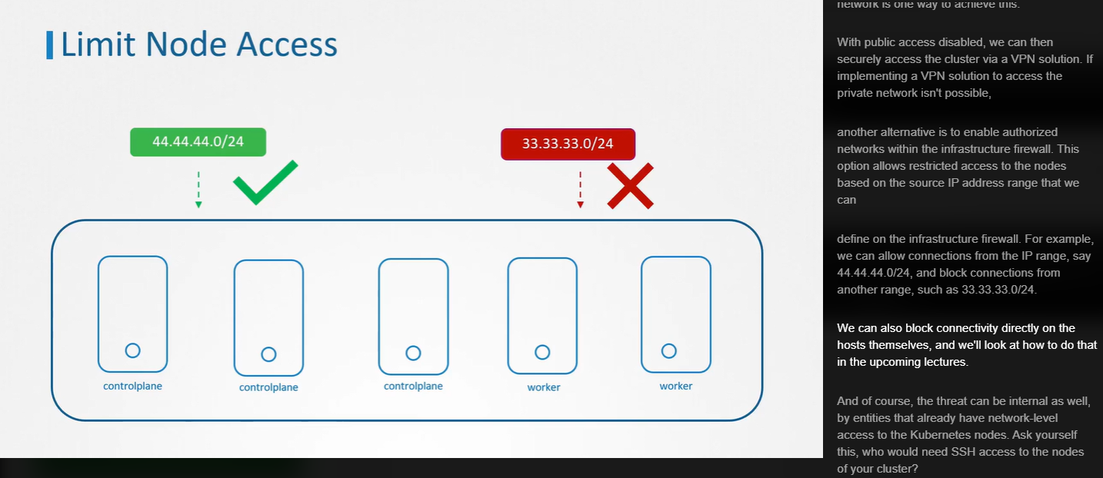

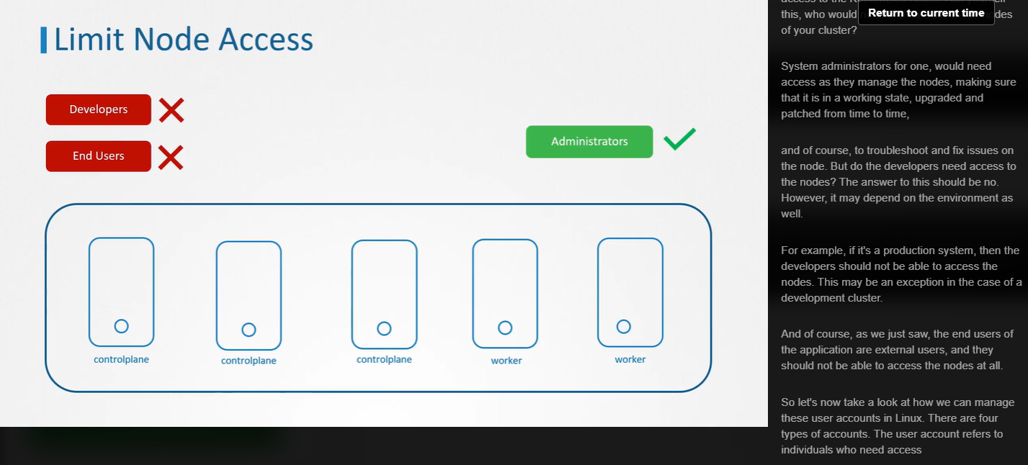

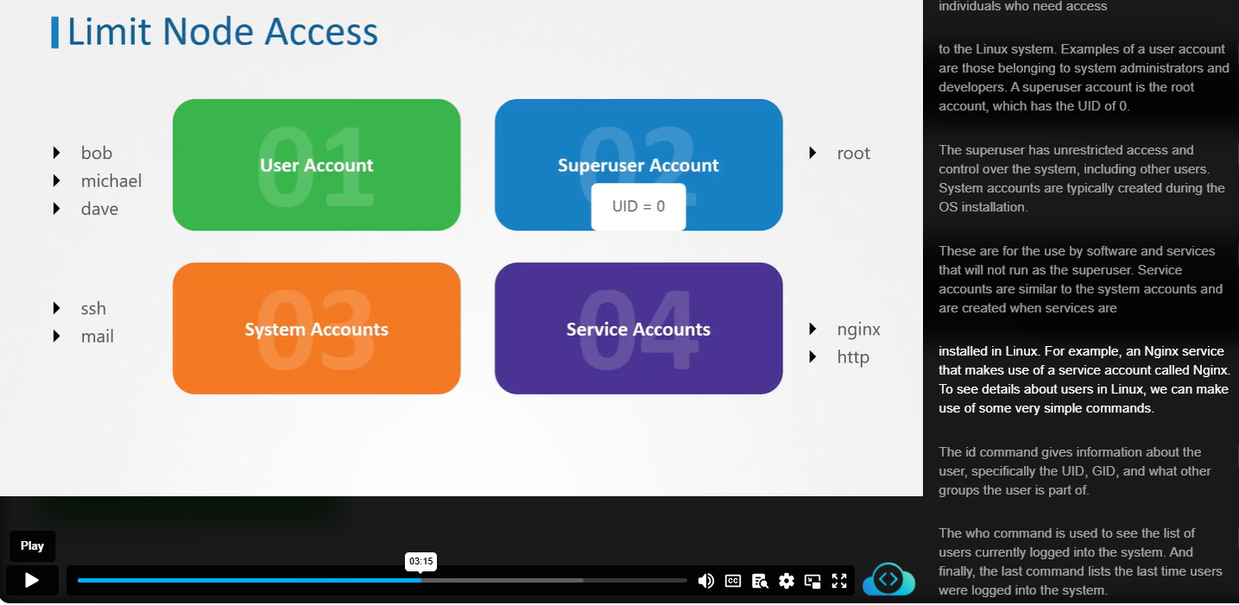

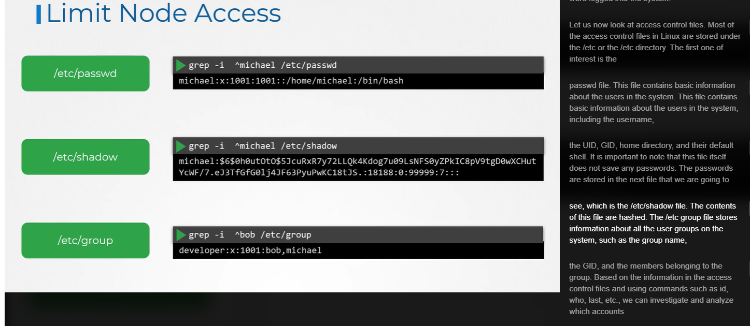

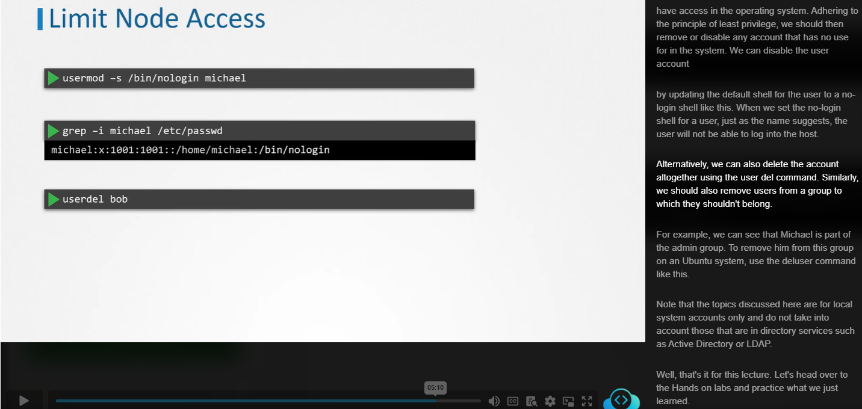

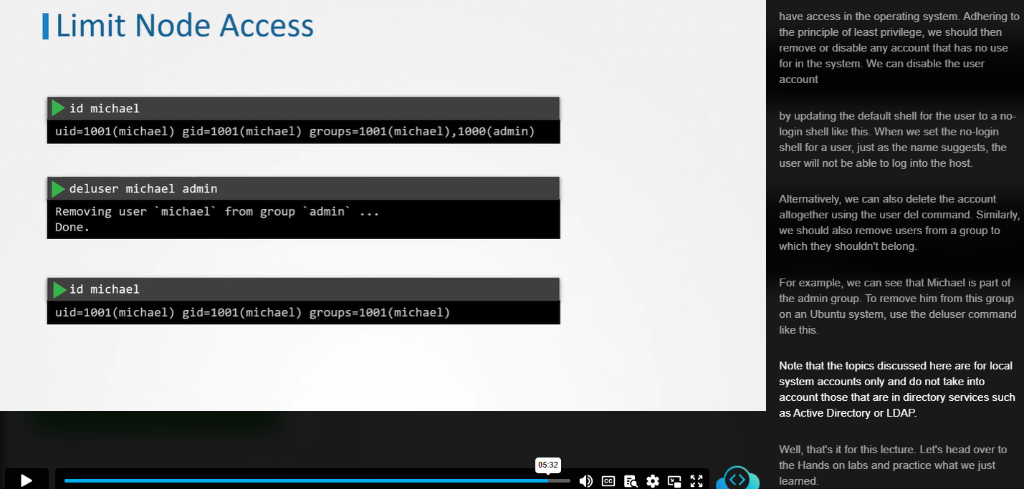

#### Ssh connection to Node –

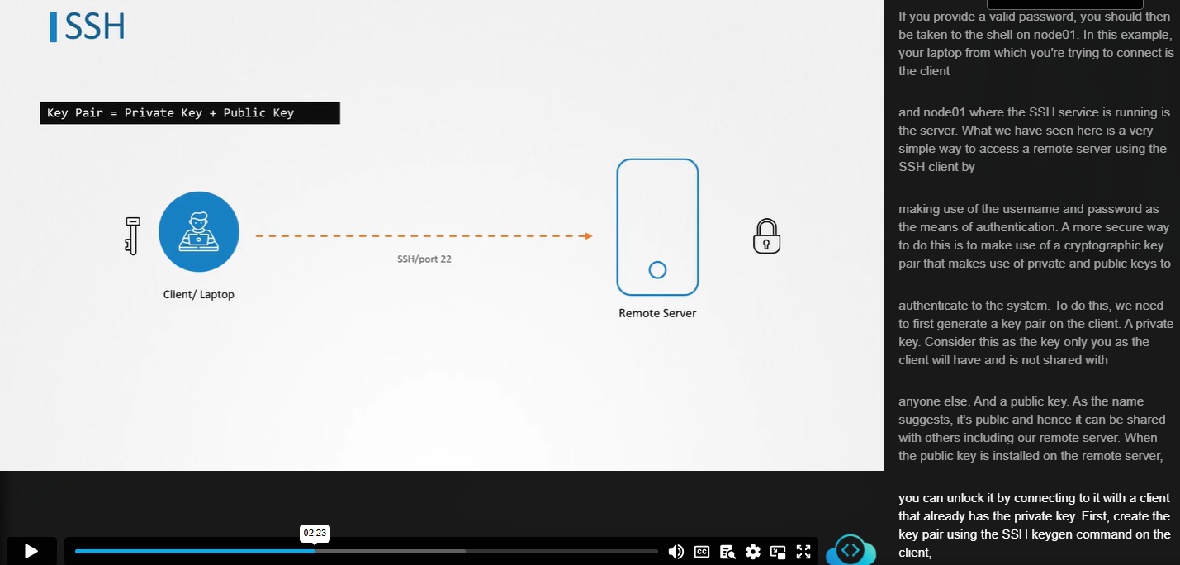

Public and Private Key

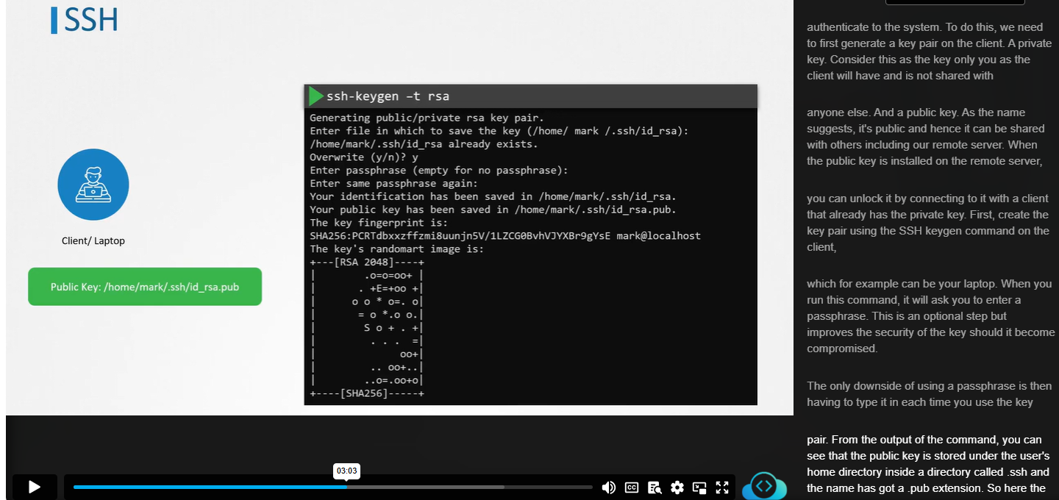

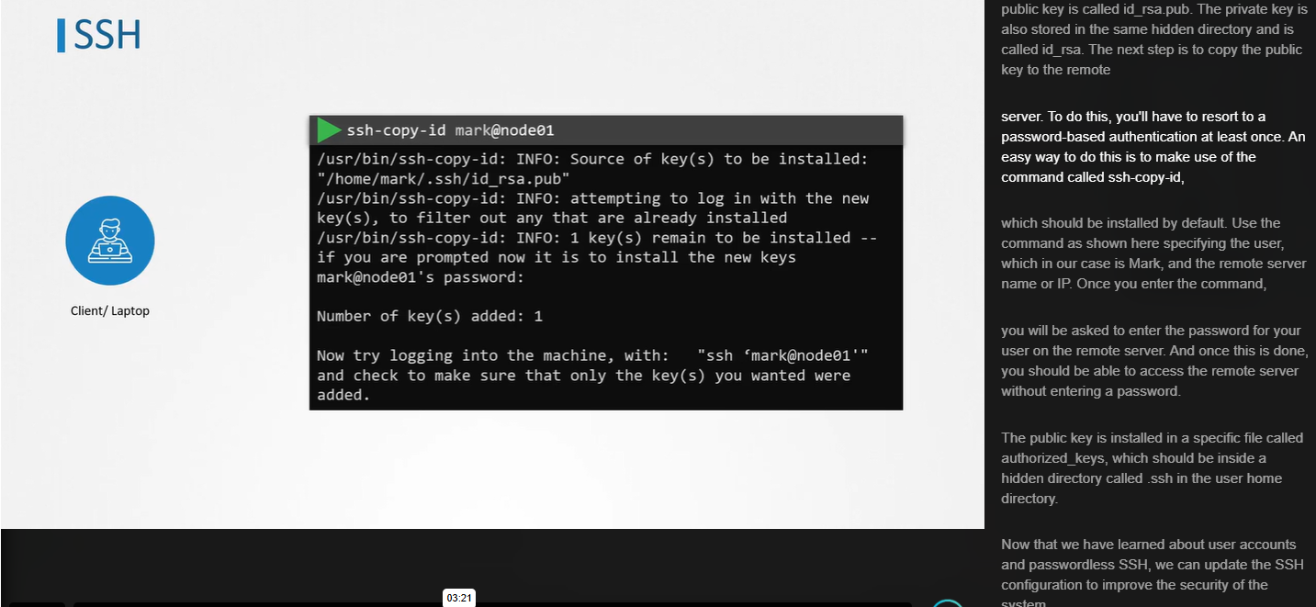

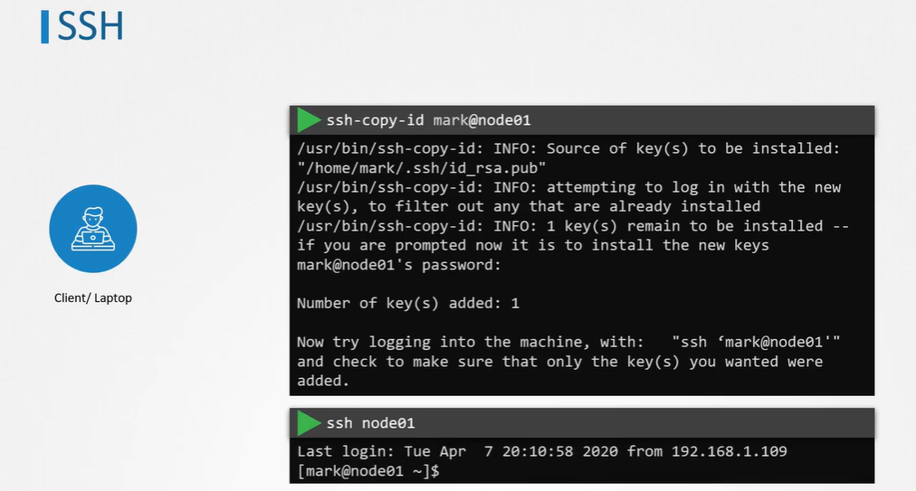

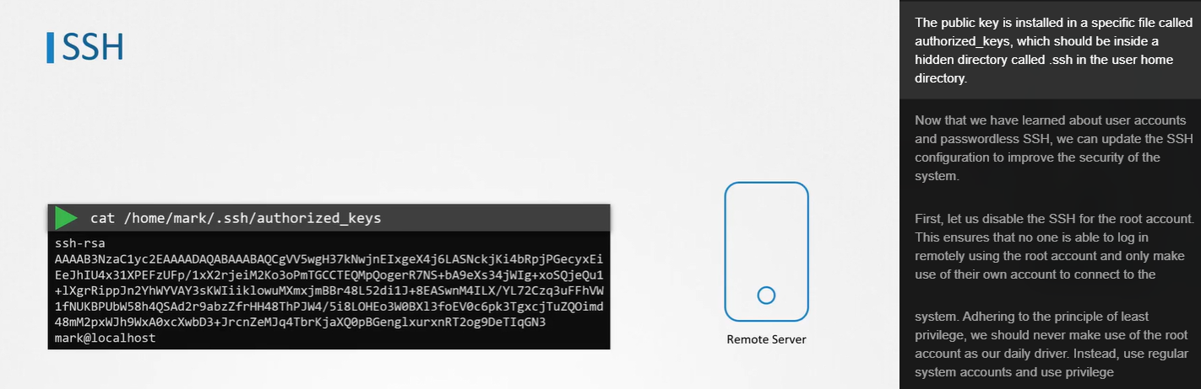

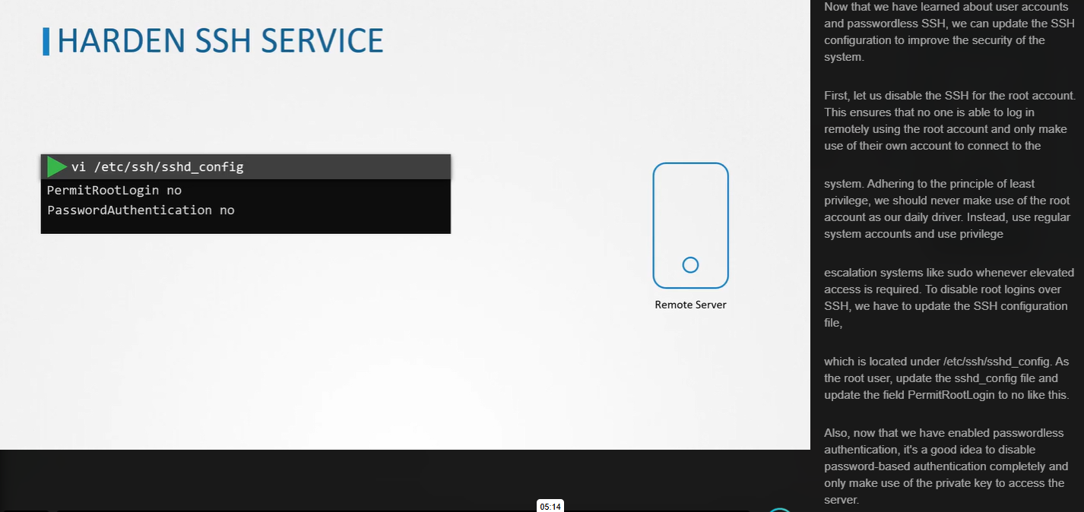

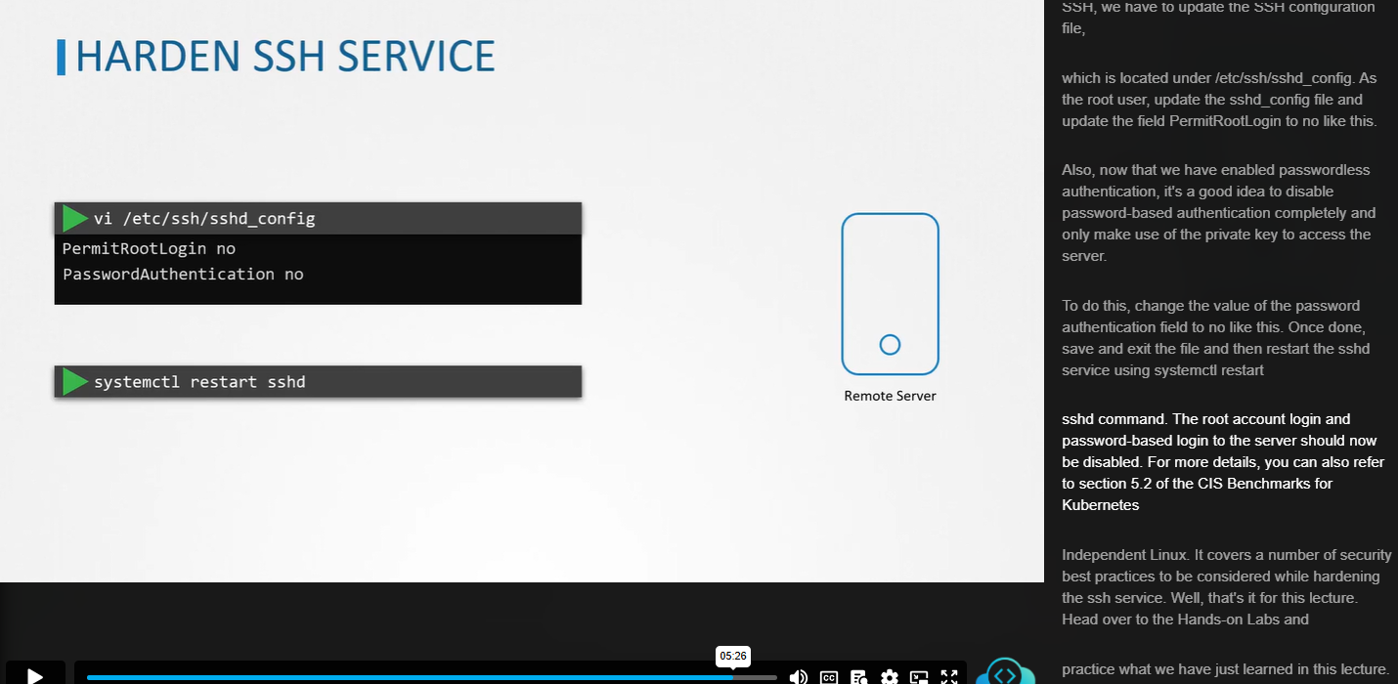

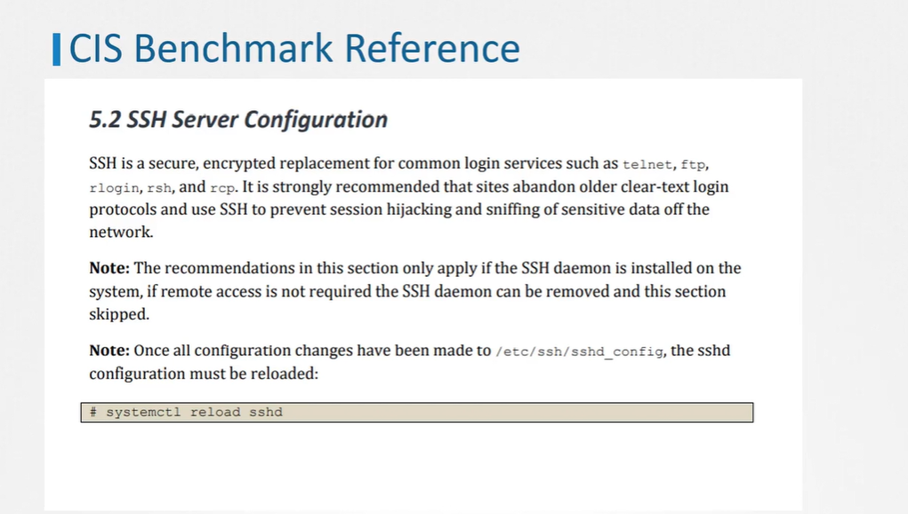

#### Sudo User:

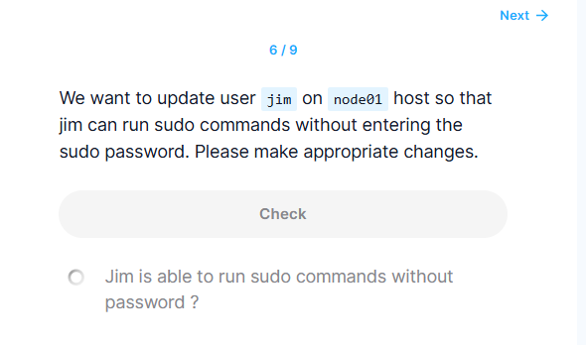

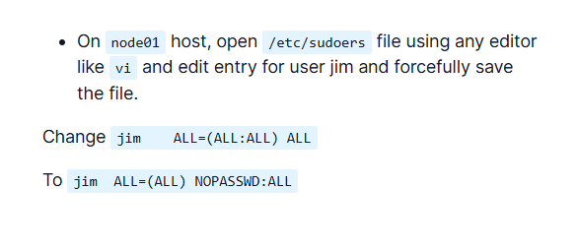

Question 2:

Add a new user rob on node01 host and set password to jid345kjf. We already have a sudo group i.e admin on this host. Make user rob member of the admin group so that he can become a sudo user. Do not to add the user directly in the sudoers file.

Answer:

* SSH into node01 host and create user rob:  
  adduser rob
* Make it member of admin group

usermod rob -G admin

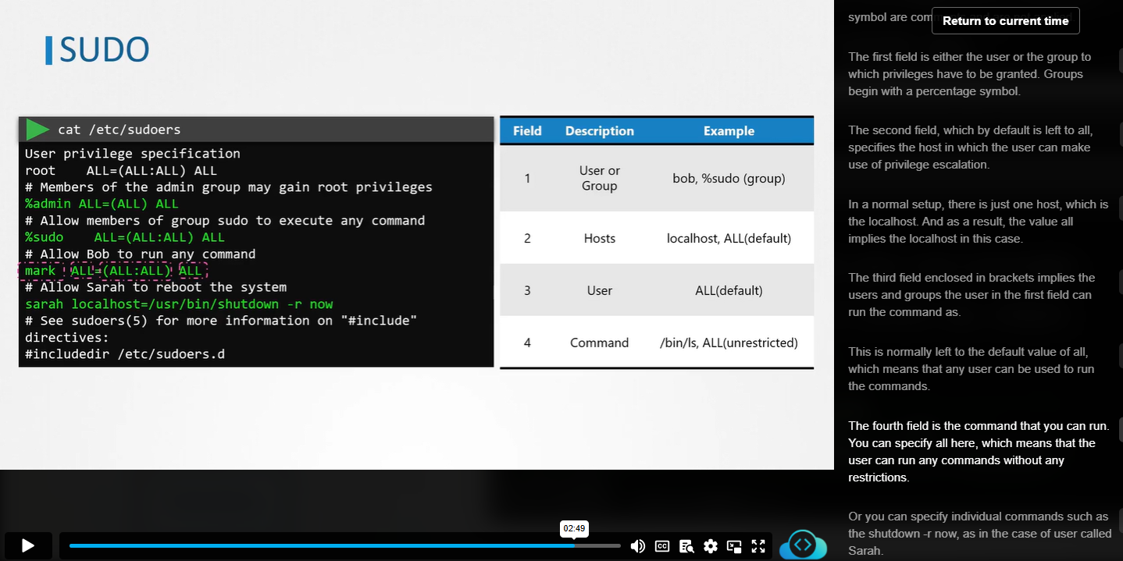

*Create a user named jim on node01 host and configure password-less ssh access from controlplane host (from user root) to node01 host (to user jim).*

* ssh into node01 host from controlplane host

ssh node01

* Create user jim on node01 host

adduser jim (set any password you like)

* Return back to controlplane host and copy ssh public key

ssh-copy-id -i ~/.ssh/id_rsa.pub jim@node01

* Test ssh access from controlplane host

ssh jim@node01

### Remove Obsolete Packages

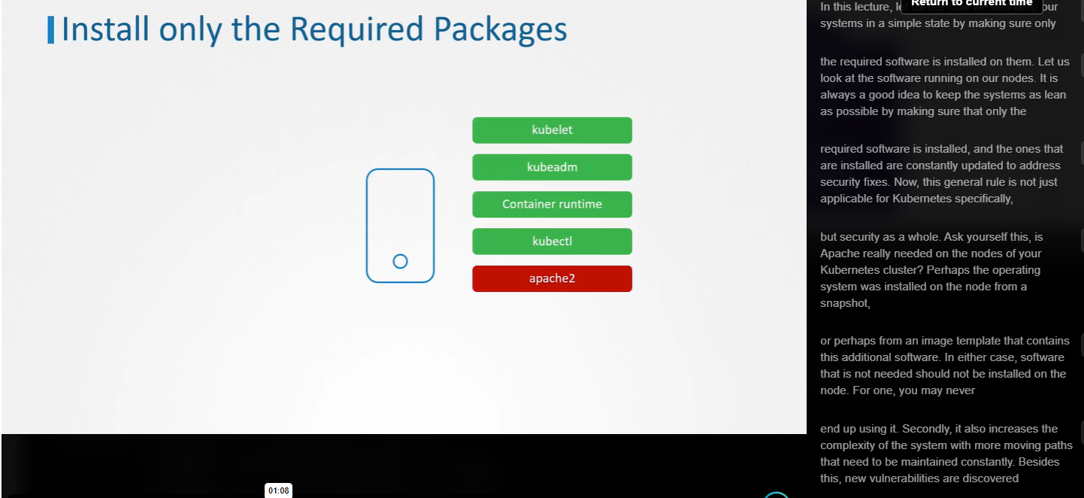

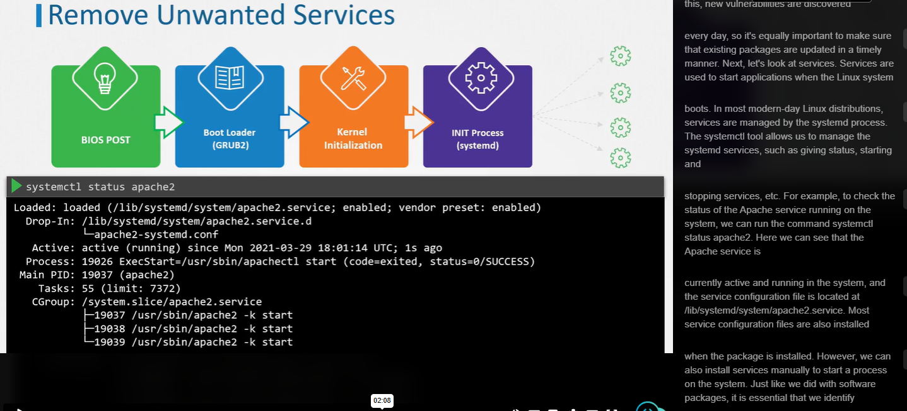

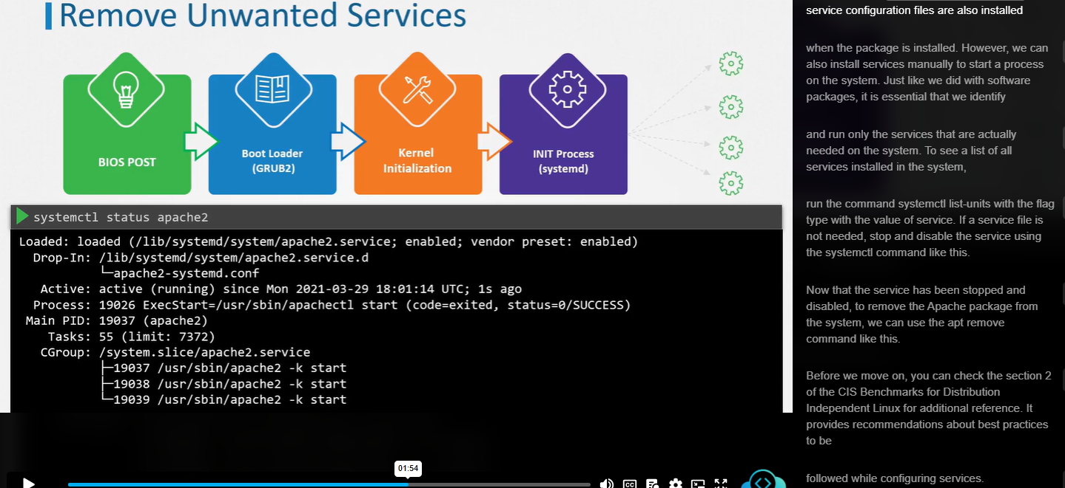

List all the services

$systemctl list-units –type service

To stop the service and disable it

$systemctl stop apache2

$systemctl disable apache2

To remove the apache

$apt remove apache2

<https://www.cisecurity.org/cis-benchmarks/>

Go to the **`Operating Systems`** section and search for the **`Distribution Independent Linux`**. Expand it to see more options, then download CIS Benchmark.

